**Flower Power**

**Playdough**

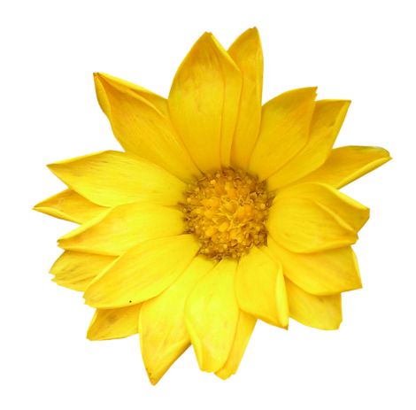

**You Will Need:**

Some colourful flower petals

½ cup of flour

1 tbsp salt

3 tbsp water

Small bowl

Sharp knife



1. First, chop up the flower petals as finely as you can.
2. In the bowl mix the flour and salt.
3. Mix in the water.
4. When dough is formed start kneading then add the flower petals.

A very pretty, easy playdough but check for allergies such as hay fever before using this recipe.

