**Green Beanstalk**

**Playdough**

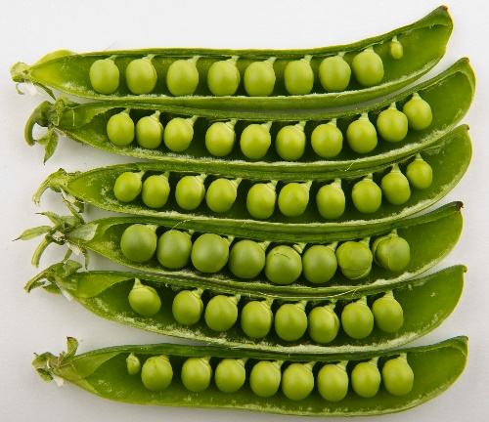

**You Will Need:**

1 cup flour

½ cup salt

2 tbsp cream of tartar

1 tbsp oil

Green food colouring

1 cup boiling water

½ cup dried green split peas

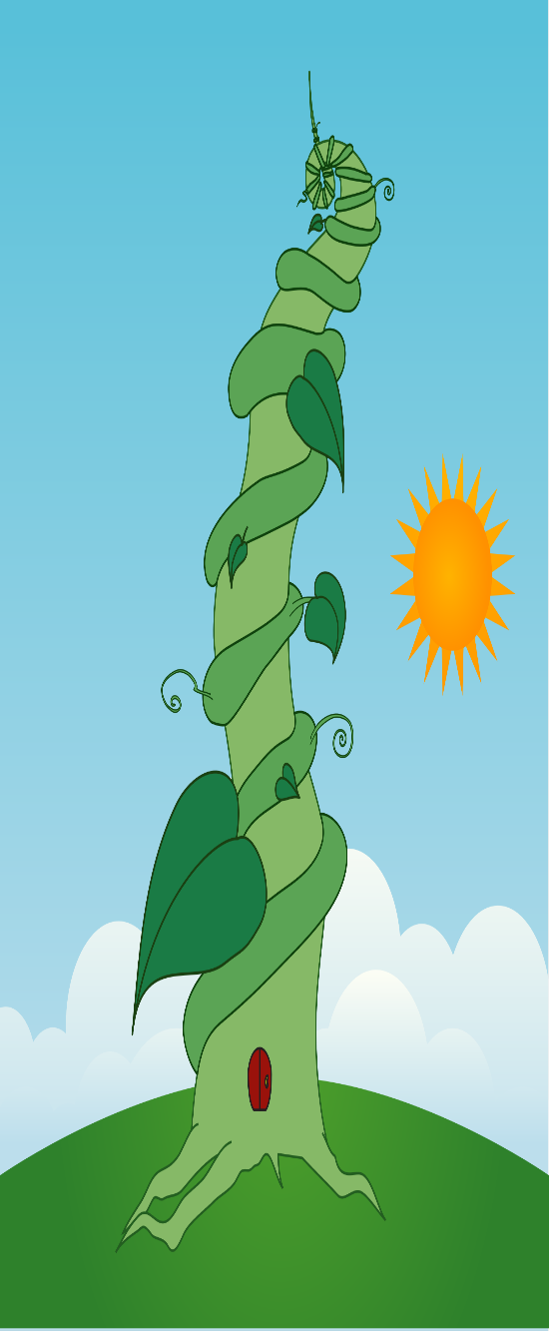

1. First, mix together flour, salt, cream of tartar and oil in a large mixing bowl.
2. Add 5 – 10 drops of green food colouring to the boiling water.
3. Add the green water to the other ingredients in the bowl.
4. Stir well.
5. Once you feel it is cool enough, knead mixture and add the split peas.

