**Funky Frog**

**Playdough**

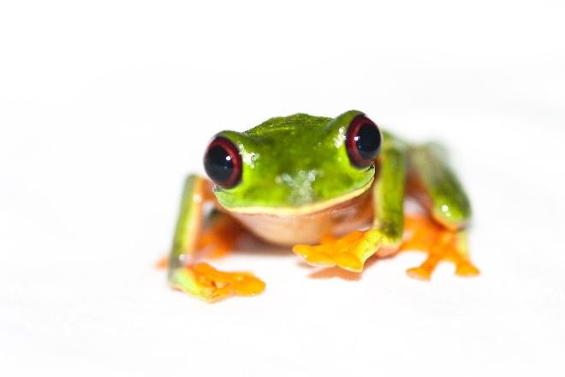

**You Will Need:**

1 cup flour

½ cup salt

2 tbsp cream of tartar

1 tbsp vegetable oil

Green food colouring

1 cup boiling water

2 tbsp baby oil

1. Mix together flour, salt, cream of tartar and oil in a large mixing bowl.
2. Add 5 – 10 drops of food colouring to the boiling water.
3. Add the water to the ingredients in the bowl.
4. Stir mixture until it is well combined.
5. Once cool enough add the baby oil.
6. Knead and get playing.

